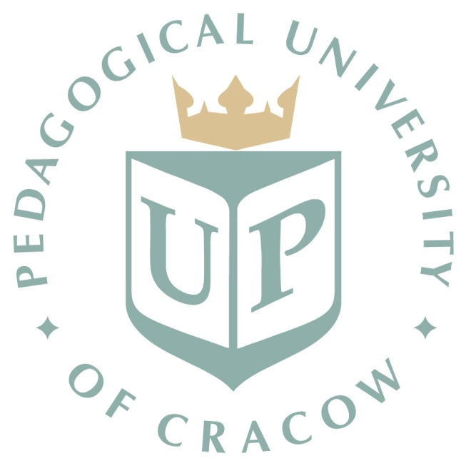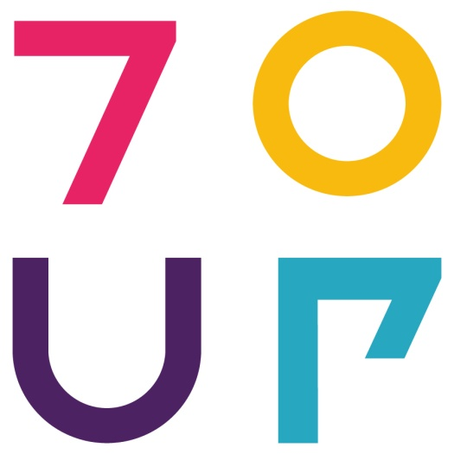

The Chair of English Language Teaching
Institute of Modern Languages, Department of English Studies
Pedagogical University, Cracow, Poland
warmly invites researchers, teacher-trainers and practitioners to the

International Conference for
Child Foreign Language Learning (CFLL).
“Between theory and practice”
Cracow, Poland, 28-30 April, 2016

Early foreign language learning is a priority for European language education policy, as evidenced by the conclusions of the Barcelona presidency (2002) with their stress on teaching at least two languages from the very earliest years.
On 1 September 2015 Poland introduced obligatory foreign language instruction at the pre-primary level, thus implementing the European language policy guidelines in respect of ‘an early start’ in a foreign language. This has made it one of the few European countries in which a foreign language (FL) is taught to very young learners. In accordance with the reform, by 2017 all kindergarten children will receive foreign language instruction, which will guarantee equal opportunities for early foreign language education.
Recent educational analysis shows that this trend has the potential to develop – in terms of research, in terms of educational innovation, and in terms of curricula and materials. Therefore, we aim to bring together professionals from all relevant fields, to create a forum for the exchange of up-to-date knowledge and experience, and to create an opportunity to summarise achievements and current research outcomes in this area. We also hope to encourage further interest in early FLL.
The plenary speakers for the conference will be

Prof. Victoria Murphy, Institute of Education, Oxford University, Great Britain
Dr Sandie Mourão, Nova University, Lisbon, Portugal
Prof. Małgorzata Pamuła-Behrens, Pedagogical University, Cracow, Poland

The conference is intended for all persons interested in the teaching and learning of foreign languages at an early age, both pre-primary and lower primary (up to around 11 years of age). We welcome theoretical papers, practical presentations and workshops from researchers and practitioners, linguists, pedagogues and teachers. The workshop sessions will take place on the 3rd day of the conference (30 April, 2016).
Each presentation will be allocated 30 minutes (ca. 20 minutes of presentation + 10 minutes for discussion), and each workshop will be allocated 45-60 minutes. The languages of the conference are English and Polish.
Potential topics for conference presentations include, but are not limited to:
- Early-learning foreign vs. second language acquisition: similarities and differences
- The competencies of the (very) young learner (metalinguistic awareness, phonological awareness, linguistic creativity etc.)
- Ways of implementing European policy in reference to early language learning
- Psycho-pedagogical aspects of teaching and learning foreign languages for young and very young learners
- Teaching language skills (listening, speaking, reading, writing) and language subsystems (e.g. vocabulary, pronunciation)
- Developing intercultural competence
- Evaluation of materials, course-books and syllabuses
- The use of new technologies (apps, internet resources, interactive whiteboards, etc.)
- Educational discourse
- Teaching foreign languages to children with special educational needs
- Social contexts of early FLL (parental involvement, teacher/school support etc.)
- Diagnosis of school readiness for a foreign language
- Young learner teacher evaluation

Publication
After the conference we plan to publish two peer-reviewed volumes: one in English and one in Polish.

Organising committee
Prof. Joanna Rokita-Jaśkow - chair
Małgorzata Marzec-Stawiarska, PhD
Agnieszka Strzałka, PhD
Albertyna Paciorek, PhD
Katarzyna Nosidlak, MA
Werona Król-Gierat, MA (conference secretary)
The conference is organised in partnership with the publishing house Nowa Era, and under the auspices of REYLL (the Research into Early Years Research Network).
Conference venue: All plenary lectures and presentation/workshops will be held at the Institute of Modern Languages, Karmelicka street 41.
Important dates:
Submission of paper/workshop abstracts: 15 January 2016.
Acceptance notification: 31 January 2016.
Deadline for payment and registration: 1 March 2016

Conference fee:
The conference fee is 350 (PLN) for Polish participants or 100 euros for foreign participants. This includes the cost of materials, refreshments and a conference dinner.
The conference fee does not include travel and accommodation costs, which have to be met by the participants themselves. A list of recommended hotels/hostels can be found on the conference website.
Abstract submission and conference registration
To register your interest in presenting a paper or organising a workshop, please fill in the registration form available on the website by 15 January 2016.

Contact: All enquiries should be addressed to: Werona Król-Gierat, MA, conference secretary childrenfllearning@gmail.com
Conference website: http://childforeignlanguagelearning.weebly.com
Twitter: @ChildFLL2016
Please check the conference website regularly for up-to-date information.

